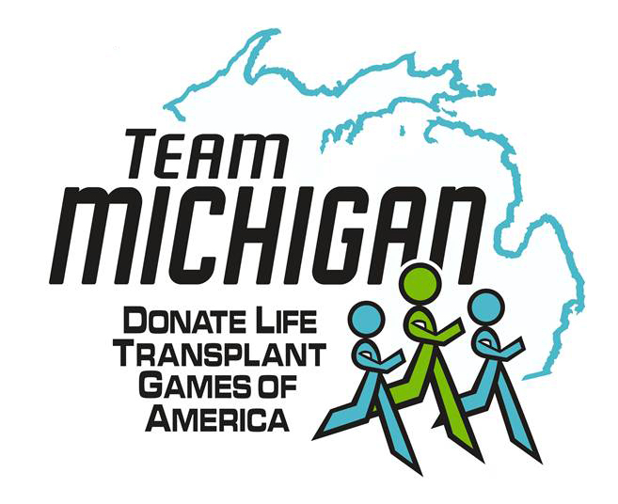

Team Michigan
Transplant Games of America
2024 Team Member Handbook

Special Thanks to the Generous
Sponsors of Team Michigan

Team Michigan Overview

Website/Facebook:
http://www.TeamMichigan.org
http://www.facebook.com/teammitransplant
http://www.Registerme.org/teamMI

Mission:
To promote organ and tissue donation awareness through participation in the Donate Life Transplant Games of America.
Goals:
Actively support the goals and objectives of the Games, including raising public awareness about organ, tissue and eye donation.
- Act as an advocate for organ donation and the team.
- Involve local communities in activities to increase awareness of organ donation.
- Encourage donor Registrations to help save lives.
Team Michigan understands the athletic desire to compete and do your best. We also hold to the philosophy that while competing as part of the games; it should never be at the expense of hurting, injuring, or being cruel to anyone attending the games.
Who is Team Michigan:
- Team Michigan has been participating in the Transplant Games for over 25 years.
- Team Michigan consists of individuals from across the state who have received life-saving transplants, also tissue, cornea, bone marrow recipients, and living donors, or families of a donor, as well as transplant professionals and advocates.
- Team Michigan provides team building events, mutual support, friendly competition, experience, and camaraderie for all our athletes, as well as having a social side for the team members. We are a not-for-profit organization run solely by volunteers. The Team is committed to the goals of all our members, from participating in one or up to five events at the American games to working toward competing at the World Transplant Games.
- Team members live throughout the state and are active members in their respective communities, promoting organ, tissue and eye donation, as well as providing educational events dispelling some of the myths associated with donation.

Events Team Michigan will be competing in:
Sporting Events –Birmingham AL July 5 -10, 2024
- 5K Run/Walk (open to public)
- Team Volleyball and Basketball
- Badminton, Ballroom Dancing, Bowling, Corn hole, Cycling, Darts, Golf
- Pickleball, Swimming, Tennis, Table Tennis, Texas Hold-em Poker, Track & Field,
- Trivia Challenge, Virtual Triathlon, Youth Olympiad, Lyrics for Life Singing Competition
Divisions of Competition:
Division 1: Solid Organ Transplant Recipients:
Recipients of a lifesaving kidney, pancreas, liver, heart, lung, intestine.
Division 11: Living Donors, Corneal & Tissue Recipients and Bone Marrow Recipients
Age Categories:
Youth: 6-10 years, 11-13 Years, Youth Olympiad, 5 & under, and 6-10 yrs
Adult: 14-17yrs, 18-29 yrs, 30-39 yrs, 40-49 yrs, 50-59 yrs, 60-69,yrs 70+
Team Michigan Uniform
- Team athletes and donor families will receive a Team Uniform.
- Each registered team athlete will receive:
- One Polo Shirt, and your choice of two t-shirts
- Donor Families will receive two complete uniforms.
- Two Polo’s and your choice of two t-shirts
- Additional items are available for purchase.
Support Team Members include:
- Transplant professionals.
- Family members, friends, members of the general public and other interested individuals who wish to support the team.
- Support Team members may purchase uniform items.
Athlete eligibility requirements:
- Athletic participation is open to any individual who has received a successful, fully functioning, lifesaving organ transplant - heart, intestine, kidney, liver, lung, pancreas, and bone marrow/stem cell - that has been functioning for at least nine months. Living donors and cornea recipients may also compete in selected events.
- Athletes participate on the team where they reside or work, not where they were transplanted.

- Athletes must provide timely submission of a physician-signed medical waiver, which should be completed and delivered to the
- Transplant Games of America, C/O Transplant Life Foundation,
Attention Medical Review Committee
1595 Galbraith Ave SE Suite 500
Grand Rapids MI 49546
Fax # 888-510-0090
Physician’s Approval to Compete Must Be Signed No Earlier Than Four Months Prior To The Start of The Transplant Games.
Donor Family Competitors Do Not Need to Submit A Medical Waiver.

- Athletes who do not have a valid medical waiver will not be allowed to participate in any athletic event.
- An adult must accompany team members 17 years old or younger.
Team Member Benefits:
Team Michigan is known to be one of the friendliest and most outgoing Teams at the Games. We pride ourselves on our helpfulness and friendliness to each other as well as other teams.
Team Michigan and the Games present compelling reasons to contribute your time, talent, and treasure to the cause of organ donation and transplantation. Team members benefit from the opportunities to:
- Support Organ, Eye, and Tissue Donation
- Represent Michigan
- Give back to your community.
- Honor organ and tissue donors and their families
- Advocate for recipient and living donor/donor family needs.
- Social networking
- Peer support, participate in the games.
Code of Conduct and Ethics:
It is the responsibility of each team member to behave in a manner consistent with the ideals and vision of the Games and in a manner that projects a positive image of the people and organizations that participate in the event. This code provides a set of basic principles to guide team members regarding the minimum behavioral and ethical standards expected. If you need help understanding this Code, or how it applies to conduct in any given situation, you should contact:
Marge Del Greco mdg0829@hotmail.com
Mike Roman mroman6730@aol.com

Team Michigan requires your commitment to:
- Meet the minimum eligibility standards to join a team.
- Uphold your role and responsibilities as a team member.
- Abide by the rules of the Games, the Team, and the policies outlined in this Handbook.
- Act honestly, ethically, and with integrity and proactively promote honest and ethical behavior among your teammates.
- Respect members of your team, other teams, spectators, volunteers, staff, and officials.
- Understand and adhere to the rules for any sport in which you participate.
- Act in a sportsmanlike manner consistent with the spirit of fair play and responsible conduct.
- Wear designated team apparel at official functions such as the Opening Ceremony, sporting competitions, media interviews, speaking engagements, and other occasions as asked by your Team Managers.
The following behaviors are strictly prohibited:
- Theft, attempted theft, possession of stolen property, conspiracy to steal or misappropriate another’s property.
- Abusive or disrespectful actions, gestures, and language (includes verbal, written, e-mail, or telephone abuse) directed at any team member or Games participant, including Team Managers, athletes, coaches, officials, volunteers, staff or other spectators.
- Any form of discriminatory behavior involving abuse or disparagement of a person’s race, religion, gender, creed, sexual orientation, age, national origin, or disability.
- Verbal, physical, or sexual harassment.
- Actual or threatened violence toward any individual or group.
- Conduct endangering the life, safety, health, or well being of one self or others.
- Violation of state, federal, or local laws.
Disagreements and Conflicts:
Dissension amongst team members, if gone unresolved, can undermine the unity and overall effectiveness of any team. Every attempt should be made to resolve disagreements and other issues directly with the individual(s) with whom you have a conflict. If for any reason, you are unable to resolve the issue, bring the matter to the attention of your Team Managers. Please keep in mind, that both parties will be given the opportunity to present their perspectives in order to assess the situation and help determine the best resolution.
Violations:
Disregard for team policies is an infraction against both your fellow team members and against those supporting the team. It is always Team Michigan’s policy to try to resolve conflict/problems in an orderly and fair fashion. Conflicts/problems that are deemed to be of severe or hurtful manner that cannot be resolved may lead to dismissal from the Team by the Team Managers.

Team Communications:
It is important to be informed and we are dedicated to providing you all the information you need to feel a part of the team, to be a productive team member, and to have a positive Games experience. We do our best to provide you with information in a timely manner via email, website, Facebook, and at the games via text and email. Remember that communication is a two-way process. Your Team Managers will make the information available. Please be proactive in obtaining it and putting it to use.

AT THE GAMES
The Games is the largest gathering of the transplant community, and the experience is one of solidarity, gratitude, comfort, fulfillment, and celebration. Many Games attendees even schedule their family vacations in conjunction with the Games when they occur every other year.
Come prepared to visit with new and old friends from near and far, to share your experiences and listen to others, to honor your loved one or a stranger, to be excited about coming in first or last place, to laugh, cry, and cheer... to be inspired! The Games are a ton of fun. And don’t forget your trading pins!
Information Updates
Team Managers attend daily meetings with the Games management staff to obtain updated information and changes regarding the next day’s events. We ask you to be proactive by helping us to disseminate what we learn to all of you,
- Please review the Donate Life Transplant Games of America website www.transplantgamesofamerica.org for times and locations of all events.

